SMSC has been at the heart of and a huge influence on all school development over recent years.

Development of a new curriculum (prep for adulthood) , PMLD / PMBL department, an additional site, new assessment framework, introduction of a total communication environment to name a few have all enriched and reinforced our capacity to deliver SMSC experiences / increase every individual understanding of the world around them as they journey through Heaton and on to their next destination

The spiritual development of pupils is shown by their:  - ability to be reflective about their own beliefs (religious or otherwise) and perspective on life  - knowledge of, and respect for, different people’s faiths, feelings and values  - sense of enjoyment and fascination in learning about themselves, others and the world around them  - use of imagination and creativity in their learning  - willingness to reflect on their experiences | At Heaton our daily assembly calendar and daily opportunities through Zones of regulation allows students to be reflective  Mon Tues Wed Thurs Fri  News Meditation Perfect day Sing & Sign Celebration  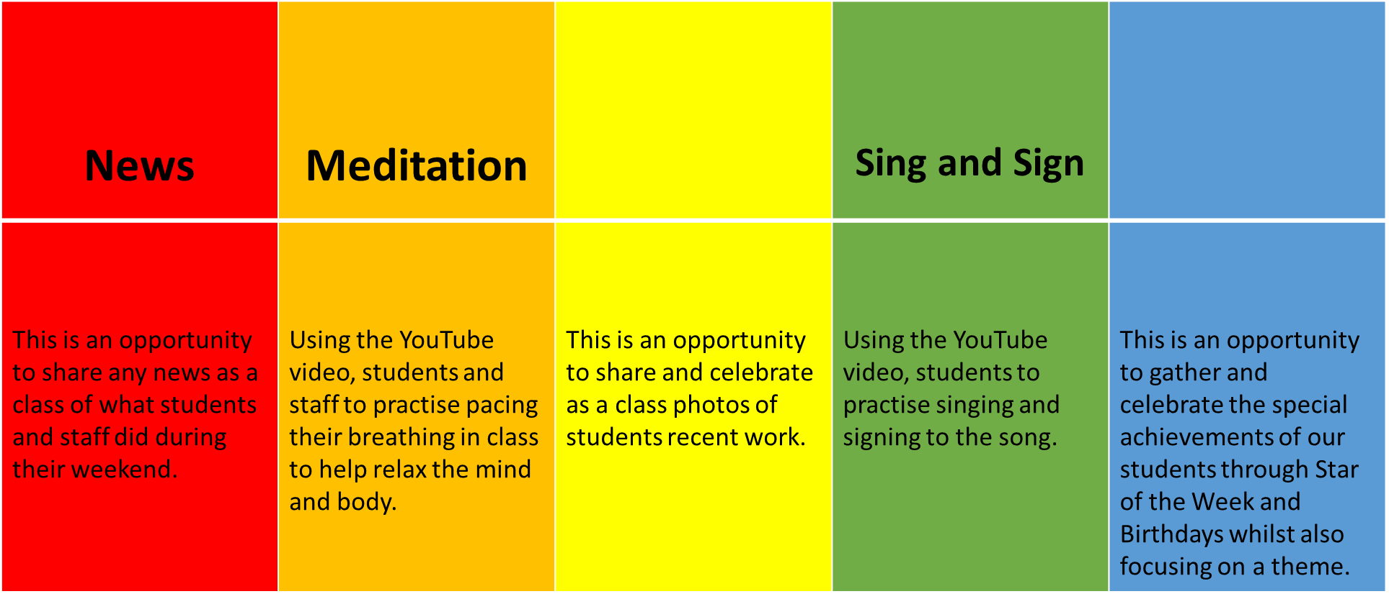  Every lesson and experience strives to give a sense of enjoyment and fascination in learning about themselves, others and the world around them.  Our curriculum is set up to achieve this with an assessment level called Understanding the world as an example
The moral development of pupils is shown by their:  - ability to recognise the difference between right and wrong and to readily apply this understanding in their own lives, recognise legal boundaries and, in so doing, respect the civil and criminal law of England  - understanding of the consequences of their behaviour and actions  - interest in investigating and offering reasoned views about moral and ethical issues and ability to understand and appreciate the viewpoints of others on these issues | At Heaton you will hear scripts that include phrases such as “making good choices” and in lessons will see turn taking as a target in lesson and IEP planning.  Students are supported to understand the impact of the simplest of choices and are given as many opportunities as possible to learn, practice and remember functional skills in real life situations in and outside of the school buildings.  Behaviour strategies are used to help students to understand that there are consequences to their actions, often these are structured and supported by communication strategies and use repetition to embed understanding over a long period of time.  We also help students to understand that its ok to be upset or make a mistake and that is part of learning on their individual journey to prepare for adulthood.  Often our students are very insula in their thinking and we support them to become more engaged with the world around them and the feelings of others.
The social development of pupils is shown by their:  - use of a range of social skills in different contexts, for example working and socialising with other pupils, including those from different religious, ethnic and socio-economic backgrounds  - willingness to participate in a variety of communities and social settings, including by volunteering, cooperating well with others and being able to resolve conflicts effectively  - acceptance and engagement with the fundamental British values of democracy, the rule of law, individual liberty and mutual respect and tolerance of those with different faiths and beliefs; they develop and demonstrate skills and attitudes that will allow them to participate fully in and contribute positively to life in modern Britain | Developing the social, communication and life skills of the students is a priority for most parents when asked what they want from the curriculum at Heaton.  We use every opportunity we can to add challenge to the students and confirm learning is embedded in different contexts / locations. Altering the context and making experiences as applicable to life outside of school as possible is very important at Heaton.  Students re all encouraged and supported to access the community as much as possible. Additional opportunities to deliver work experience, volunteering around school and community visits are prioritised where possible and appropriate.  Through special days, plenary sessions in classes we implement an understanding of the values needed to be an effective member of society and modern Britain.  Acceptance of the differences we all have is part of every day at Heaton and part of every class’s day.  We take part in special days to recognise the beliefs of different faiths and take part in whole school days such as Red Nose day / comic relief / children in need etc  Our school council reflects and allows us to demonstrate democratic processes at a level that is more relevant for many students and is accessible and impacts them directly..
The cultural development of pupils is shown by their:  - understanding and appreciation of the wide range of cultural influences that have shaped their own heritage and that of others  - understanding and appreciation of the range of different cultures in the school and further afield as an essential element of their preparation for life in modern Britain  - ability to recognise, and value, the things we share in common across  cultural, religious, ethnic and socio-economic communities  - knowledge of Britain’s democratic parliamentary system and its central role in shaping our history and values, and in continuing to develop Britain  - willingness to participate in and respond positively to artistic, musical, sporting and cultural opportunities | As above using special days to engage in and experience religious festivals and occasions around the world.  Heaton Schools ethos is one of acceptance and you will see that each individual is nurtured, appreciated and valued for who they are and what their abilities are and where they come from, not what their disabilities / barriers to learning dictate.  Our cultural studies curriculum offers opportunities to learn about other cultures and amerce the students in the experience in a sensory encounter and exploration of each individual cultural influence.  Special weeks for cultural / arts, reading / communication and maths are run throughout the year and are themed to create curiosity and foster enjoyment from a variety of cultures (eg – Eurovision week 2021)
Spiritual, Moral, Social and Cultural (SMSC) development is the over-arching umbrella that encompasses personal development across the whole curriculum.
- We judge ourselves as outstanding on our current self-evaluation in the area of personal development

