RE & Collective Worship Policy 2022

Heaton School Policy Record

RE & collective Worship Policy Agreed at:

Teaching & Learning Committee 11.10.22
Signed and Approved by:

Headteacher --------------------------------------------- (Signature)

--------------------------------------------- (Name)

--------------------------------------------- (Date)

Chair of Committee--------------------------------------------- (Signature)

--------------------------------------------- (Name)

--------------------------------------------- (Date)

To Be Reviewed: September 2024

Designated person: J Curtis, Headteacher

RELIGIOUS EDUCATION (RE):
RE at Heaton School is unique due to the varying and complex needs of the students. We believe that our students have the ability to experience a sense of awe and wonder and we aim to provide them with as many opportunities to experience this as possible, even though they may not have the ability to understand in depth the ‘why’ and ‘how’ of religion.
RE is not delivered as a discrete subject on the timetable, but is delivered through a variety of multi-sensory workshops and collapsed timetable mornings or afternoons enabling students to experience a more immersive exploration of one of the 6 World Religions. Therefore, at Heaton School we believe RE should be a multi-sensory experience with opportunities for students to experience and explore colours, tastes, textures, smells, music or sounds associated with religions or special events. Where appropriate this should be developed, for those students who have the ability to discuss and explore the more complex and abstract ideas linked to religion.

COLLECTIVE WORSHIP:
Collective worship at Heaton School is unique, reflecting the varying and complex needs of our students. At Heaton School, collective worship is set within the context of daily classroom collective reflections and a weekly Friday Assembly, which classes can attend either in person or virtually. This approach is to ensure that students are given daily opportunities to develop their sense of self, stillness, reflection and opportunities to experience a sense of awe and wonder.

Aims and Purpose
During collective worship we aim to:
• Fulfil statutory requirements of a daily act of collective worship for all students.
• Reflect on values that are of a broadly Christian character and on our own beliefs.
• Allow a pause for reflection and stillness in the midst of the pressure of the school day.
• Develop a community spirit, a common ethos and shared values.
• Provide a variety of opportunities for spiritual, moral, social and cultural development.
• Provide opportunities for expressing shared experiences and interests and for celebrating special occasions together.
• Provide opportunities in which students interact with other year groups, staff and on occasions the wider community, as well as offering opportunities to perform and respond to a presentation of readings, music, dance, drama or prayer.

The SCHOOL COMMUNITY
Assemblies are non-denominational and conducted in a manner which is sensitive to the faiths and beliefs of all members of the school community. Assemblies are also an opportunity to celebrate the achievements and learning of the students. We encourage students to participate by recognising and celebrating a ‘Star of the Week’ during which students may show their work and share successes with others. This also plays an important part in promoting the ethos of Heaton school - that all student’s diversity and achievements are celebrated. Assemblies are regarded as a special time in the day, provide periods of calm reflection and are conducted accordingly. Students are encouraged to behave respectfully and thoughtfully and are encouraged to come in and leave assemblies in a respectful manner.

COLLECTIVE WORHSIP WEEKLY ROTA
Whole School Assemblies are normally led by the Headteacher, deputy head or other members of Staff, but are sometimes led by visitors to the school e.g. local Religious groups. We have a Daily assembly calendar that is adapted to suit each class and learner appropriately

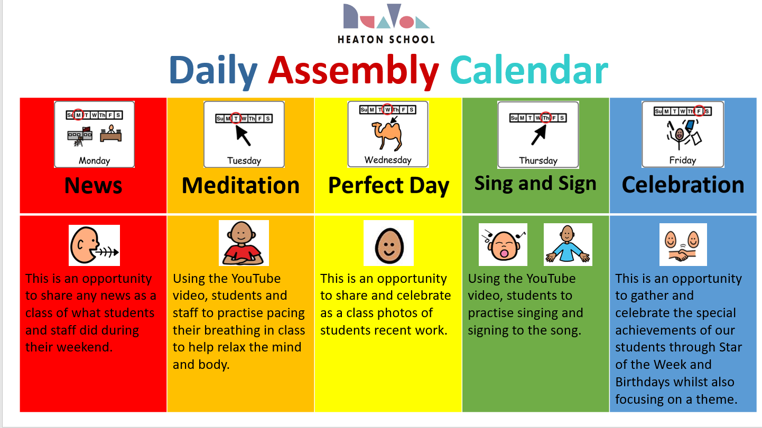

CLASSROOM COLLECTIVE REFLECTIONS
During classroom collective reflections we aim to:
• Provide greater opportunity to participate and respond.
• Provide opportunities for deeper thoughts and feelings in a more intimate setting.
• Personalise reflection to the students’ age and abilities.

RIGHT OF WITHDRAWAL
The school accepts the right of parents to withdraw their child from RE and collective worship if they so wish. In this event please make an appointment with the Headteacher or RE Subject Lead Mr Keane to discuss further.

